[**IBM-Project-49854-1660881153**](https://github.com/IBM-EPBL/IBM-Project-49854-1660881153/upload/main)

**Plasma Donor Application**

Team ID : **PNT2022TMID23657**

* Team Leader : M.Pooja
* Team member :V.Nehaa
* Team member :G.Suvetha
* Team member :S.Srinithi

**Status** :

* Ideation Phase - done
* Problem Statement - done
* Project Design & Planning (1) - done
* Project Design & Planning (2) - done
* Project planning - done
* Sprint 1 - done
* Sprint 2 - done
* Sprint 3 - done ● Sprint 4 - done

# INTRODUCTION

## Project Overview

Plasma is a critical part of the treatment for many serious health problems. Therefore, there are blood drives asking people to donate blood plasma. The main goal of our project is to make it easier for the COVID-19 patients to get a plasma donor easily as well as donate plasma if they have recovered. The system targets two types of users: the people who want to donate plasma and the people who need plasma. The user can also view the total active cases, nearby vaccine centres, hospitals address.

The main objective of developing the website is to make it easier for the COVID-19 patients to get a plasma donor easily and as soon as possible. Yet, the need for plasma-derived products has been strongly increasing for some years, and blood collection agencies have to adapt if they want to meet this demand. This article aims to review the main motivations and deterrents to whole blood donation, and to compare them with those that we already know concerning plasma donation. Current evidence shows similarities between both behaviours, but also differences that indicate a need for further research regarding plasma donation.

## Purpose

During the COVID 19 crisis, the requirement of plasma became a high priority, and the donor count has become low.

Saving the donor information and helping the needy by notifying the current donors list, would be a helping hand. Regarding the problem faced, an application is to be built which would take the donor details, store them and inform them upon a request.

# LITERATURE SURVEY

## EXIXTING PROBLEM

* Only web-based system is available no mobile based system is available
* Less Security
* No proper coordination between different applications and users
* Cannot upload and download the latest updates at right time • Fewer users-friendly

## REFERENCE

Several experiments have been carried out over the years by different groups of researchers. Here are some of the following groups:

1. Denuis O'Neil (1999). "Blood component" Archived from the original on June 5, 2013.
2. ways to keep your plasma healthy, Original Archived November 1, 2013, Accessed November 11, 2011.
3. Ripathis S, Kumar V, Prabhakar A, Joshi S, Agarwal A (2015). "Microscale Passive Plasma Separation: A Review of Design Principles and Microdevices," J. Micromech Micro 25 (8): 083001;
4. P. C. P. C. a. V. I. M. Yan, “Building a chatbot with server less computing,” IBM watson research center, 2016. [5] S. E. a. B. J. J. Short, ““Cloud Event Programming Paradigms:

Applications and Analysis,”,” 9th IEEE International Conference on Cloud Computing (CLOUD), pp. pp. 4 00-406, 2017.

### Problem Statement Definition

During COVID 19 crisis the requirement for plasma increased drastically as there were no vaccinations found in order to treat the infected patients.

In such situation it was very difficult to find the plasma donor, check whether the donor was infected previously and was recovered, and which donor is eligible to donate plasma was a challenging task.

As the plasma therapy was one of the ways to treat the infected patients getting the donor details played a major role.

**IDEATION AND PROPOSED SYSTEM**

**EMPATHY MAP**

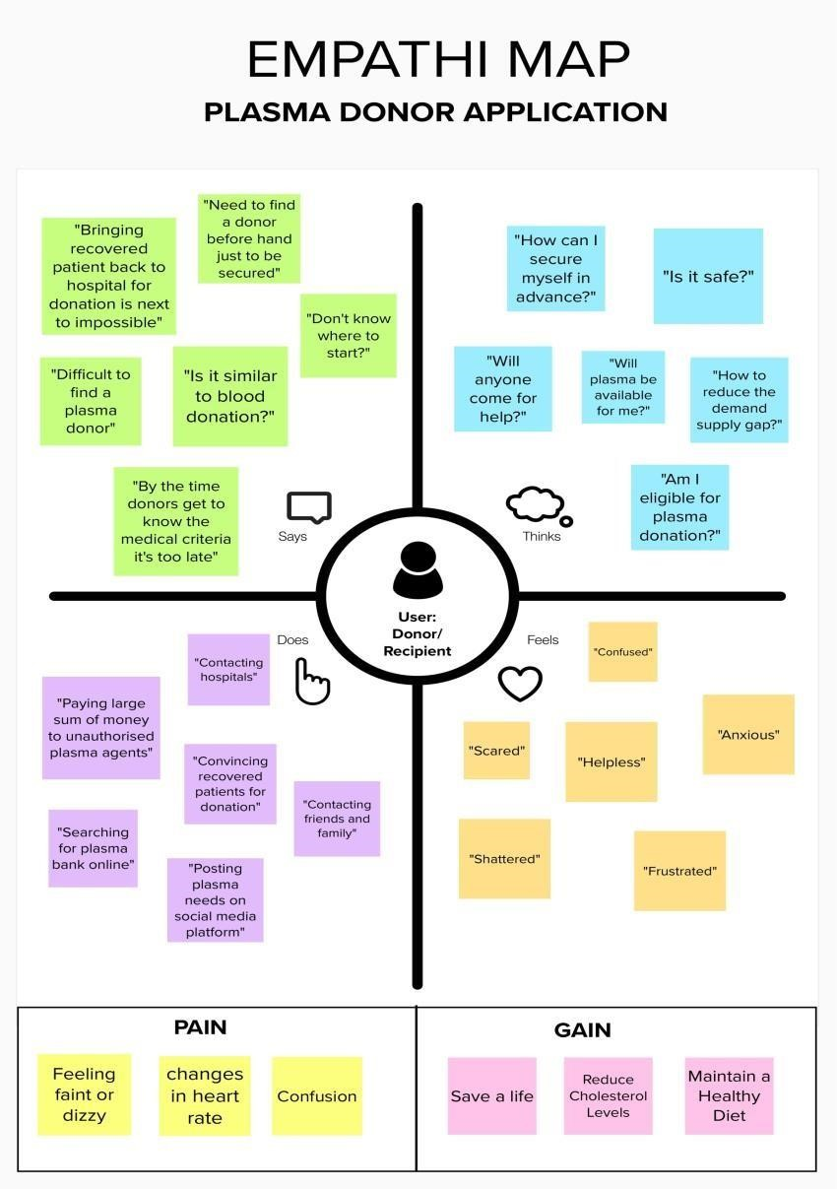

**IDEATION AND BRAINSTORM**

Step-1: Team Gathering, Collaboration and Select the Problem Statement

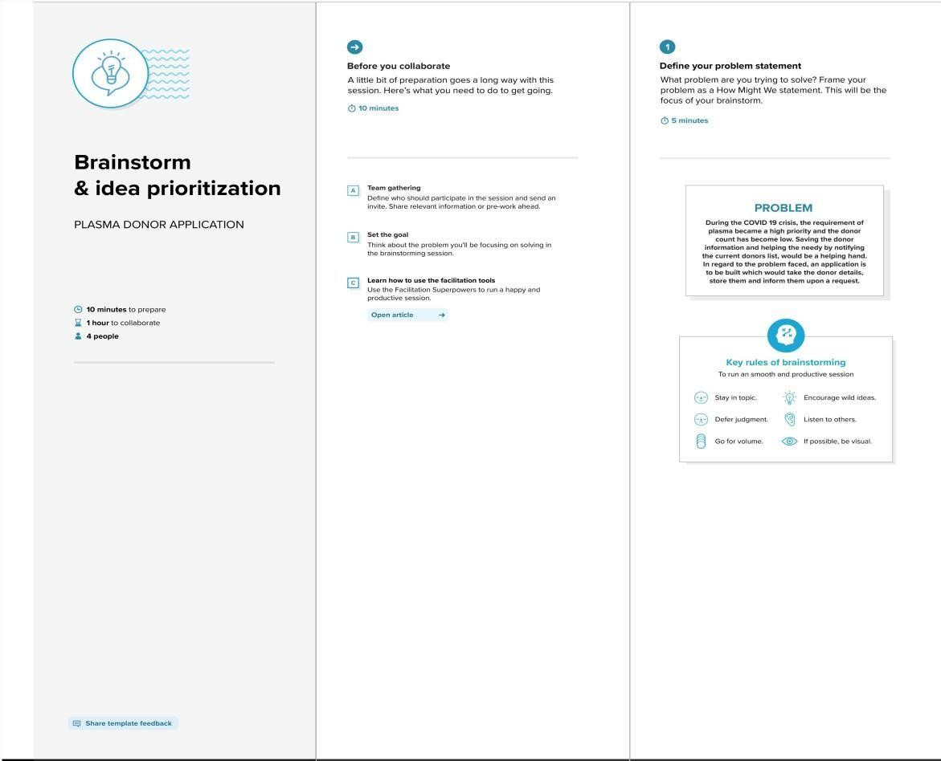

Step-2: Brainstorm, Idea Listing and Grouping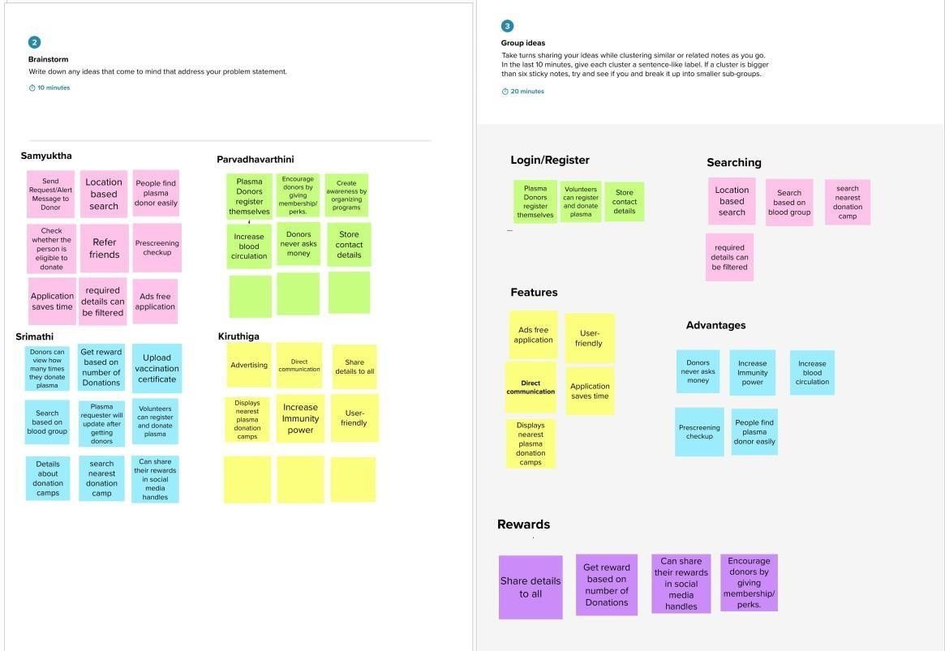

Step-3: Idea Prioritization

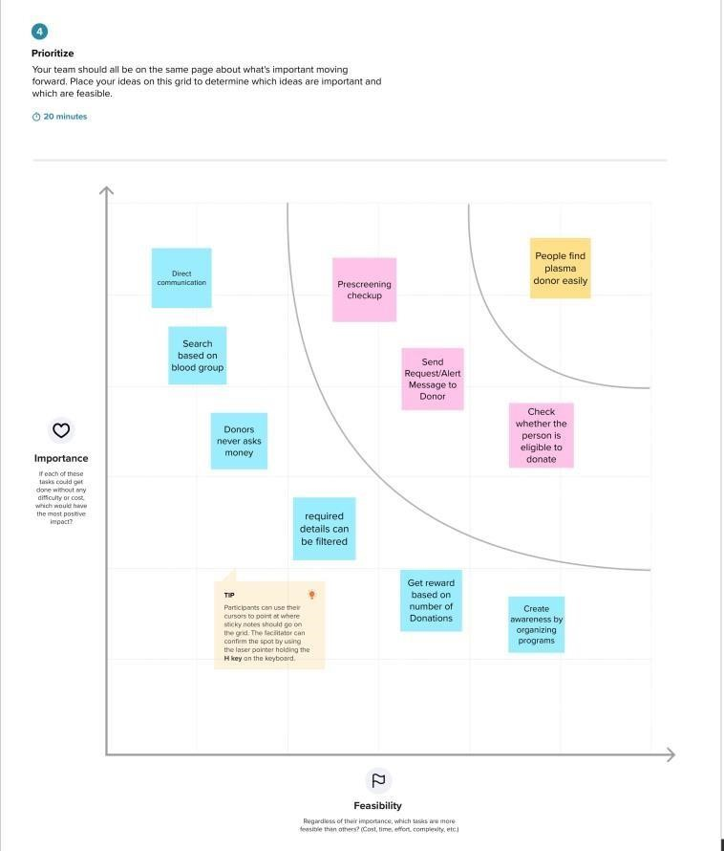

**Project completed**

GITHUB Files

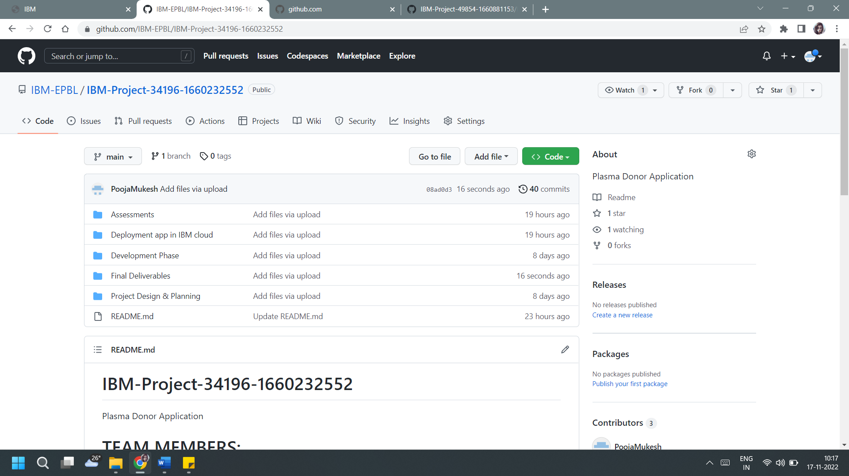

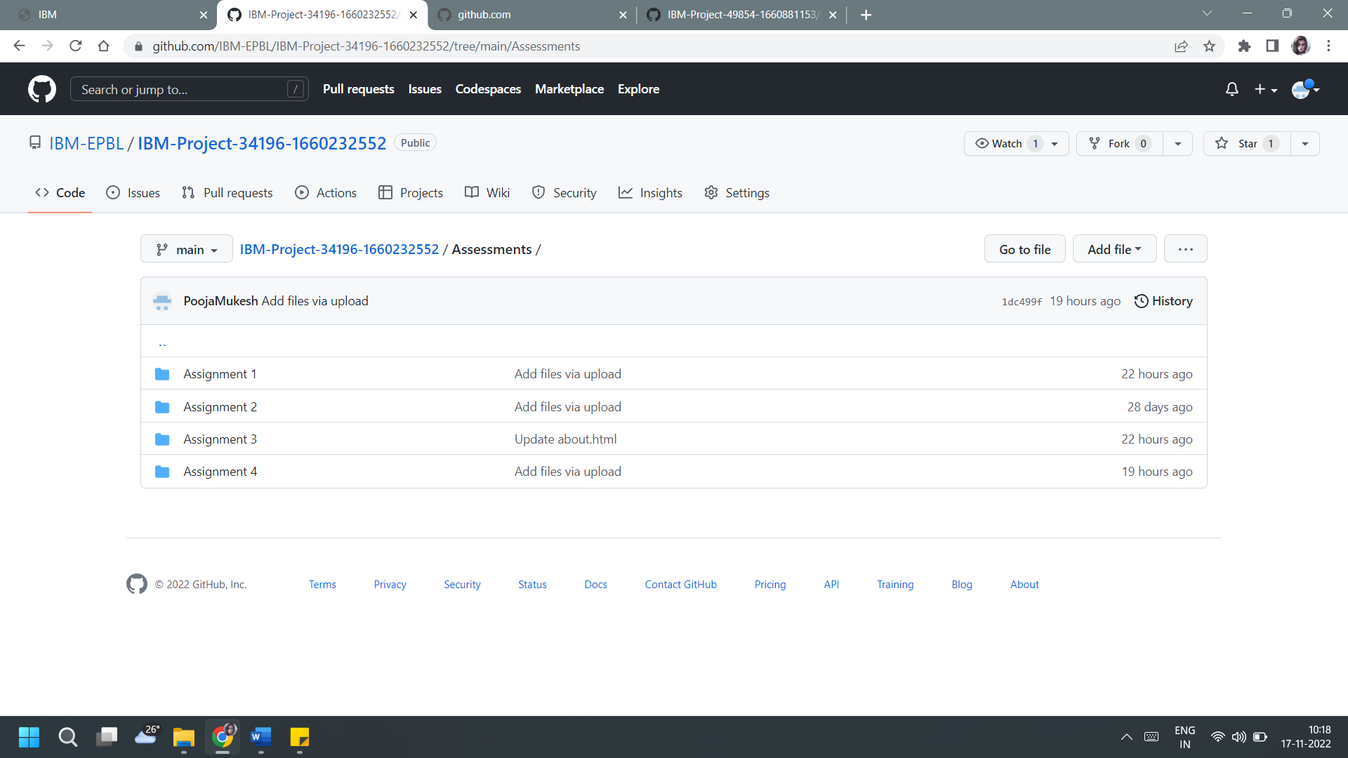

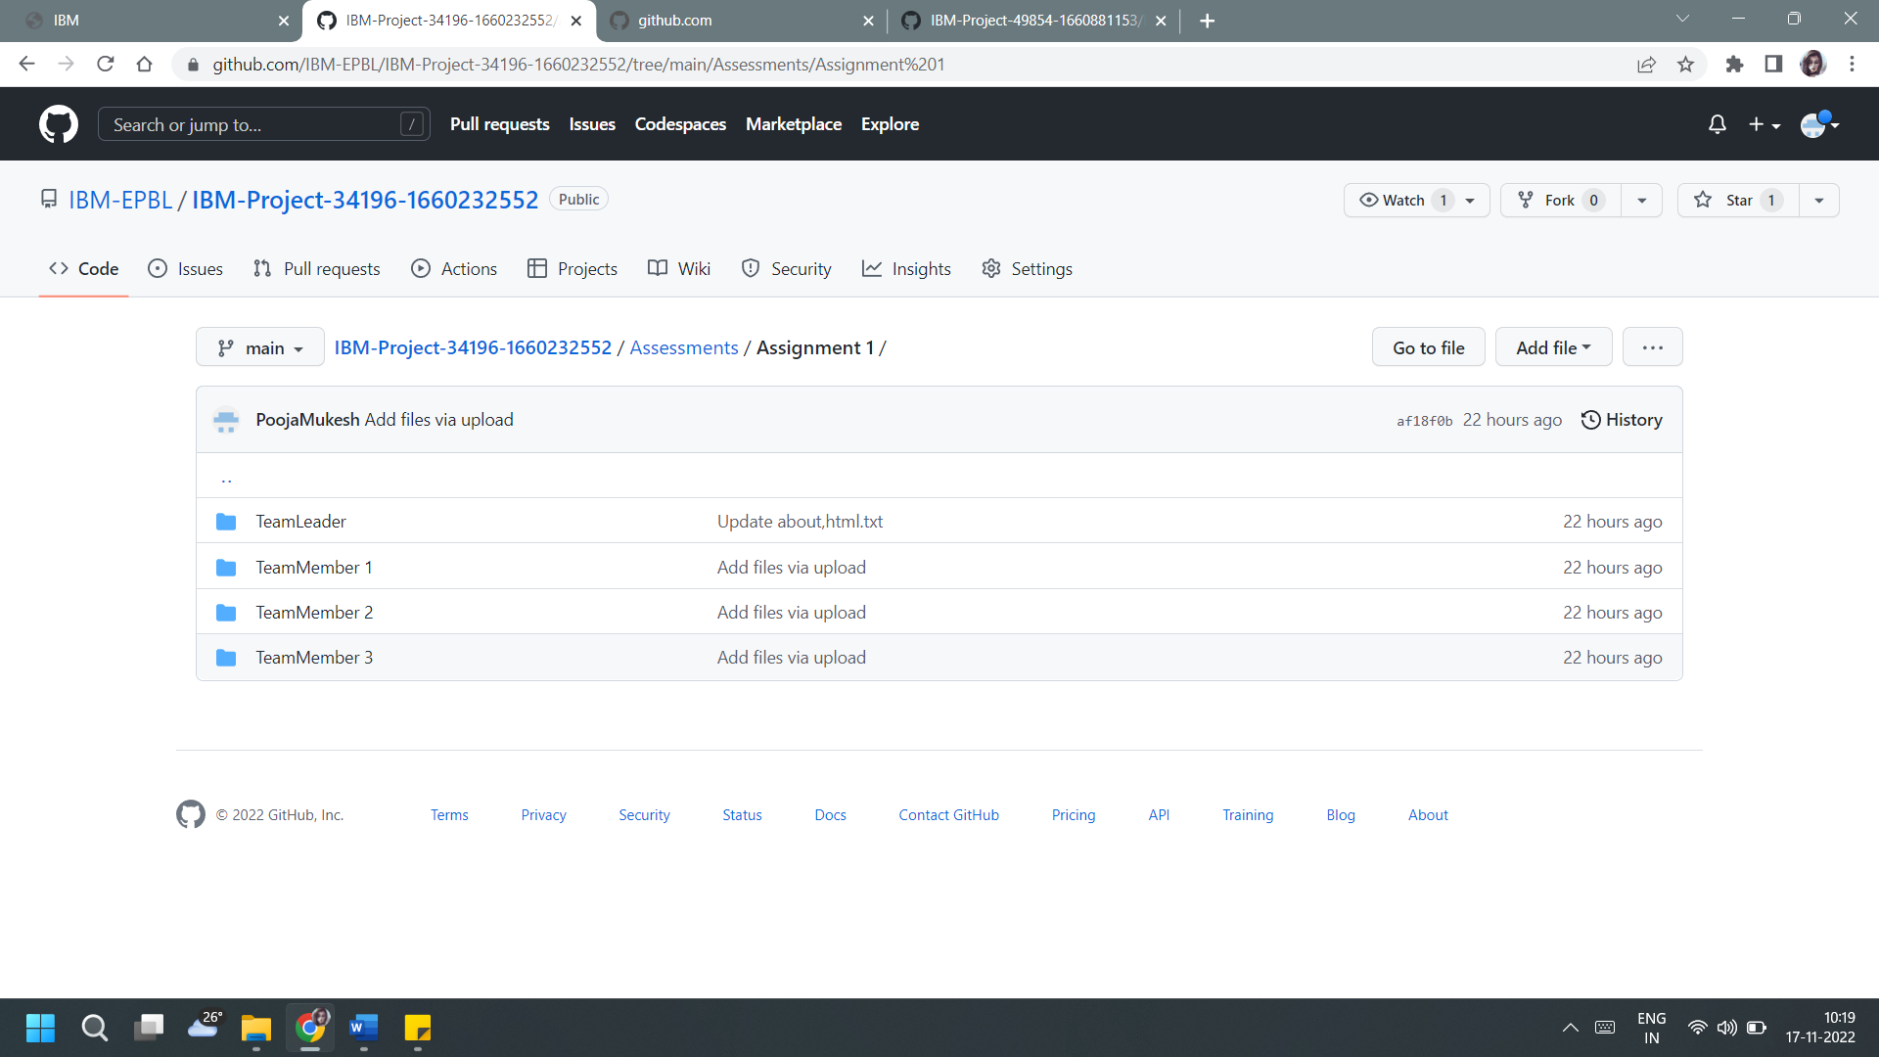

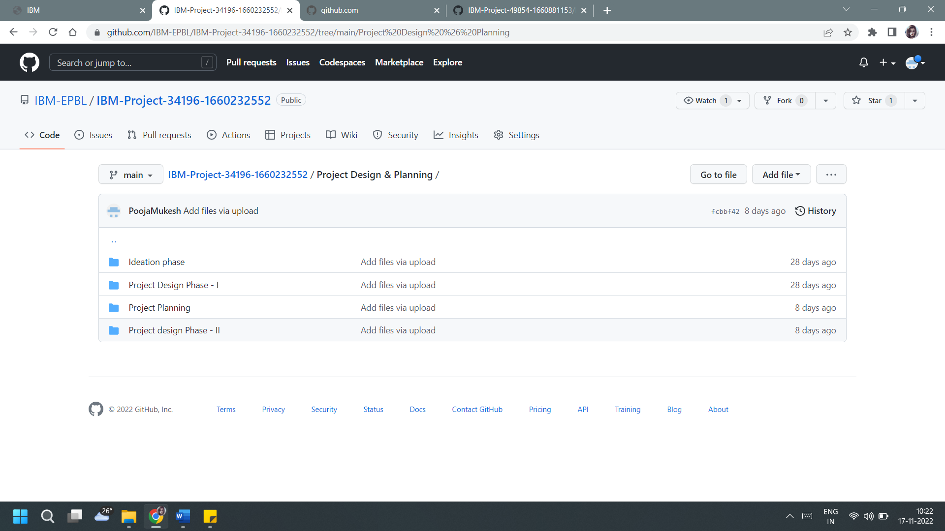

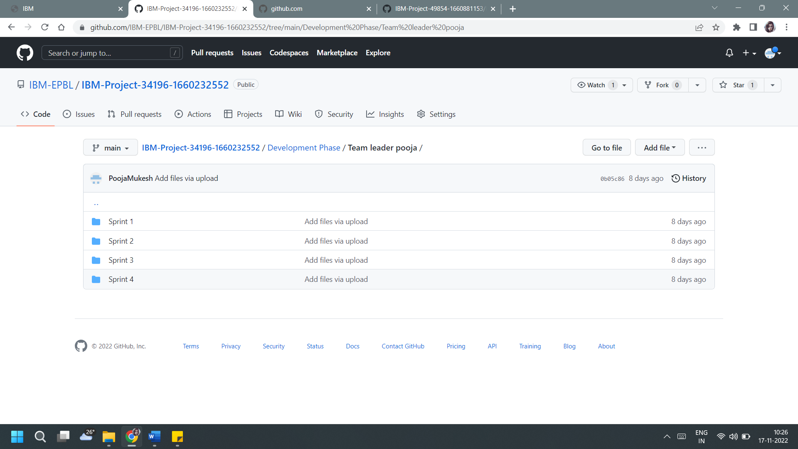

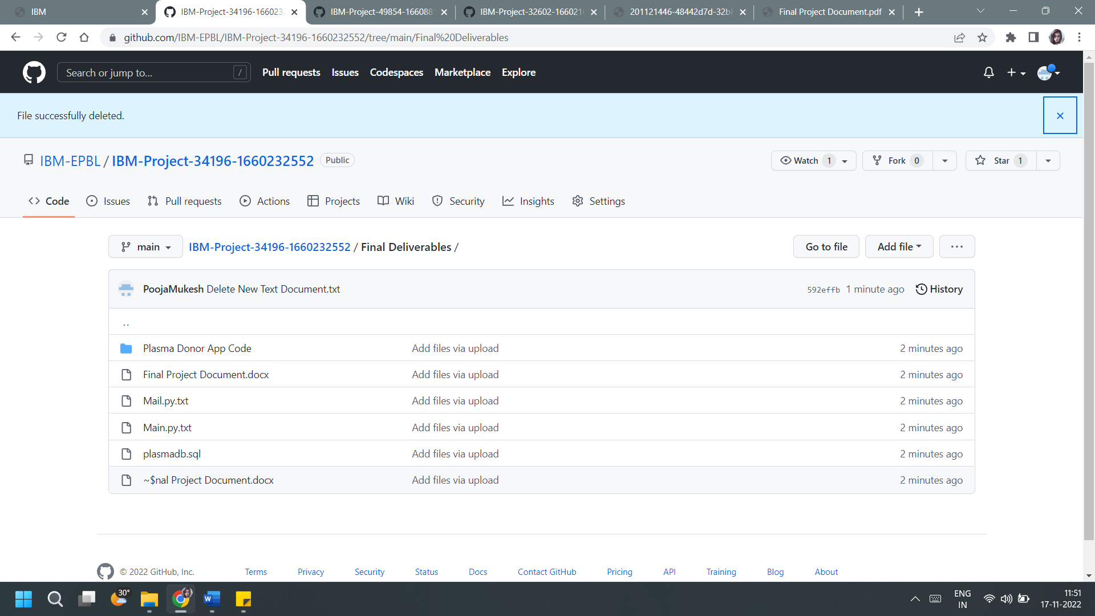

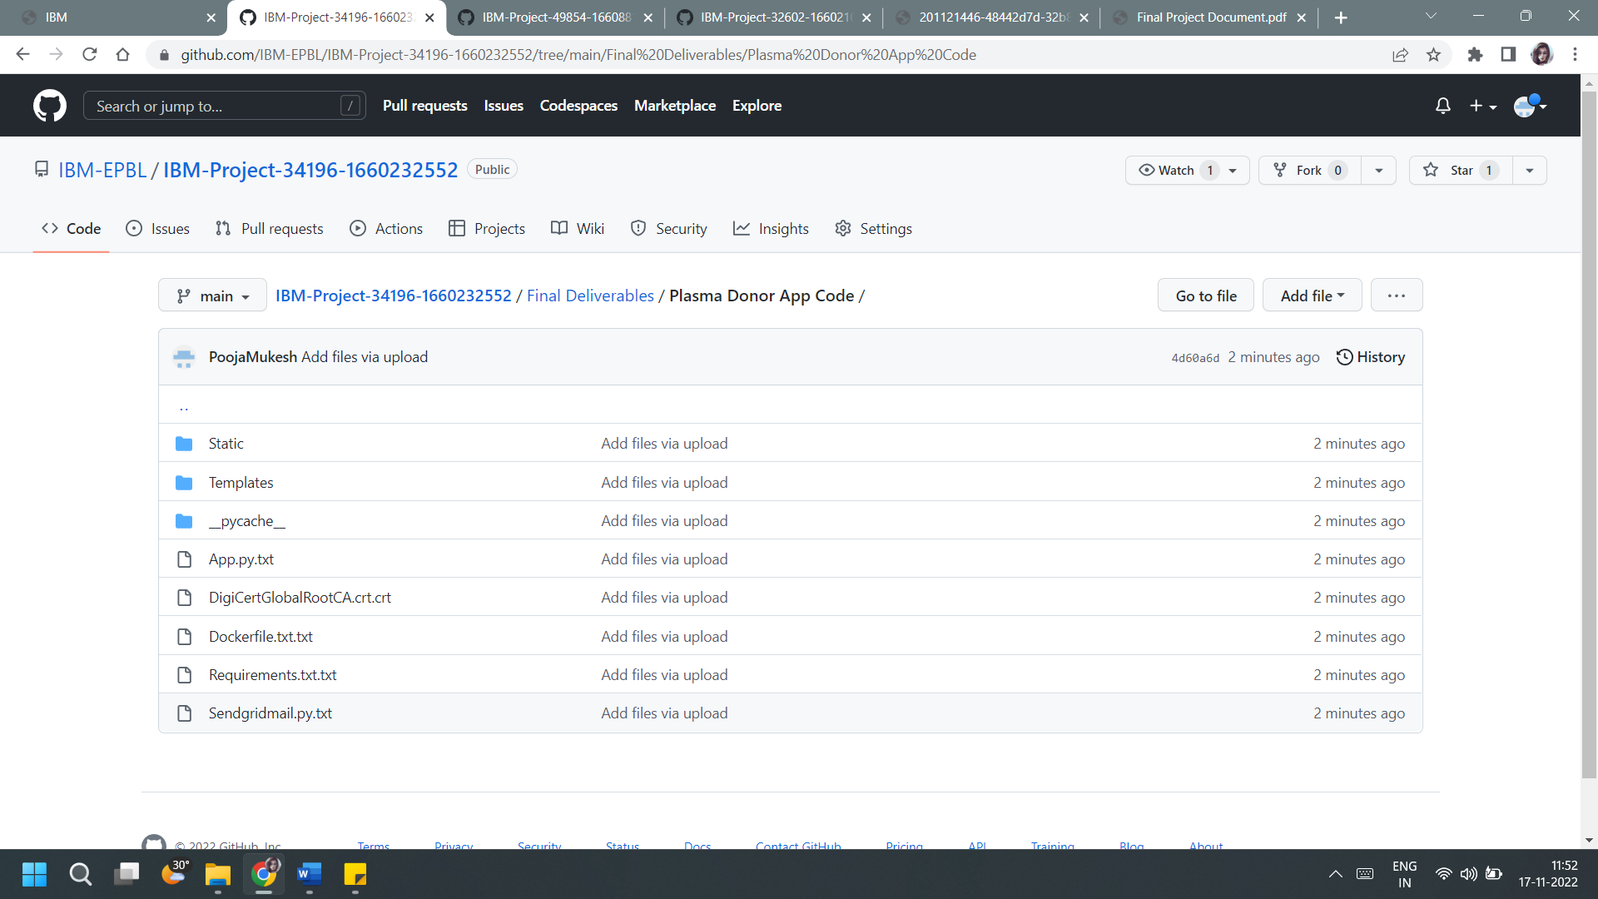

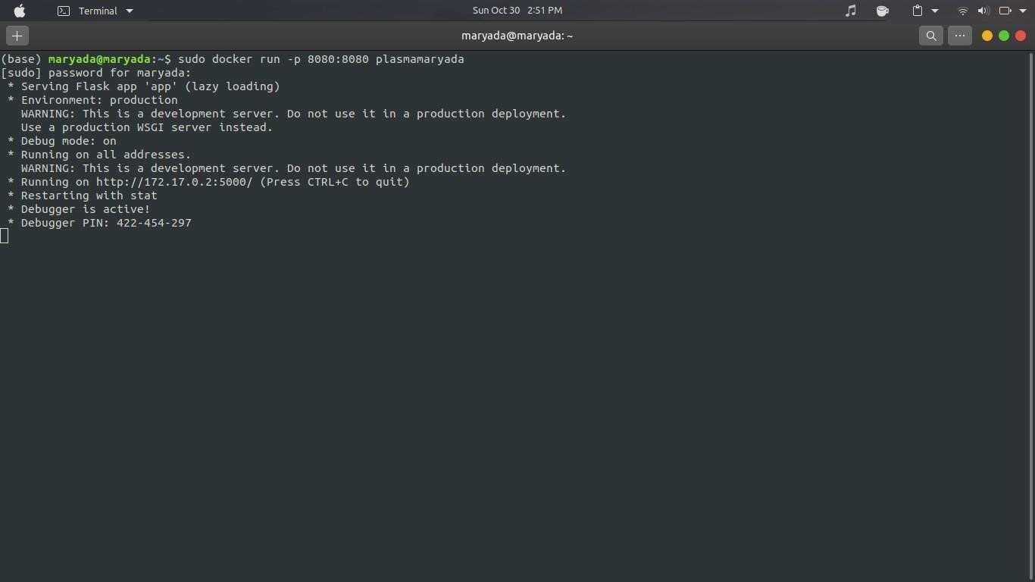

[**SETTING UP APPLICATION ENVIRONMENT**](https://careereducation.smartinternz.com/Student/guided_project_workspace/40734#collapse1)

[**IMPLEMENTING WEB APPLICATION**](https://careereducation.smartinternz.com/Student/guided_project_workspace/40734#collapse2)

[**INTEGRATING SENDGRID SERVICE**](https://careereducation.smartinternz.com/Student/guided_project_workspace/40734#collapse3)

[**DEPLOYMENT OF APP IN IBM CLOUD**](https://careereducation.smartinternz.com/Student/guided_project_workspace/40734#collapse4)

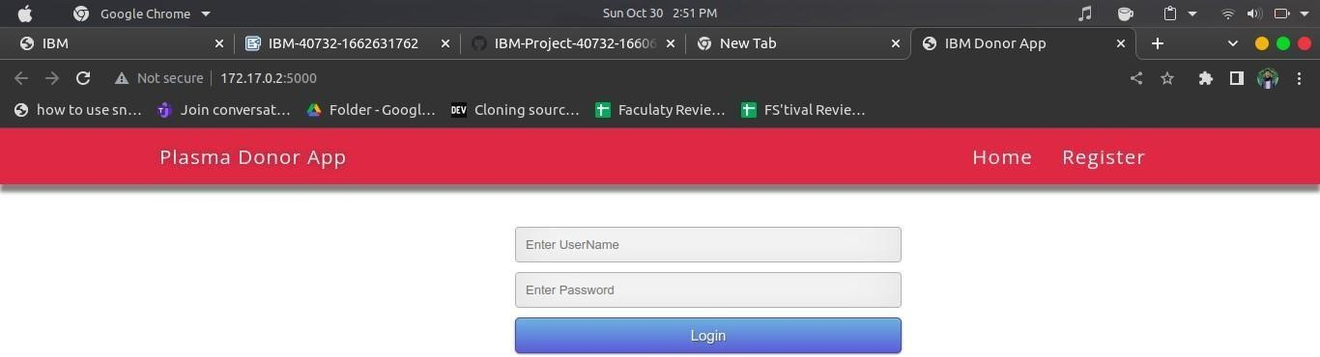

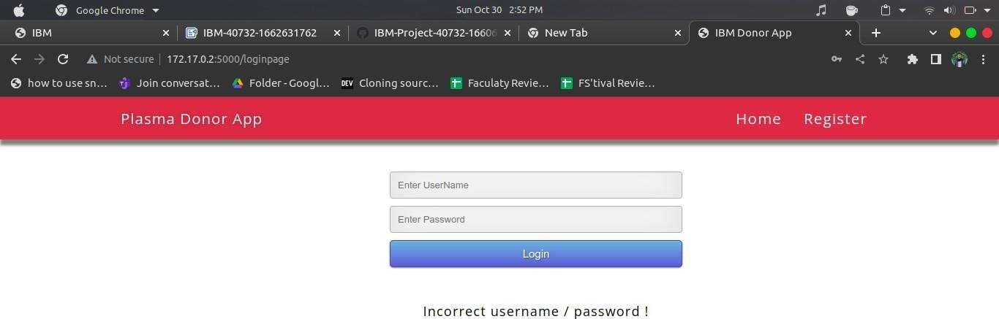

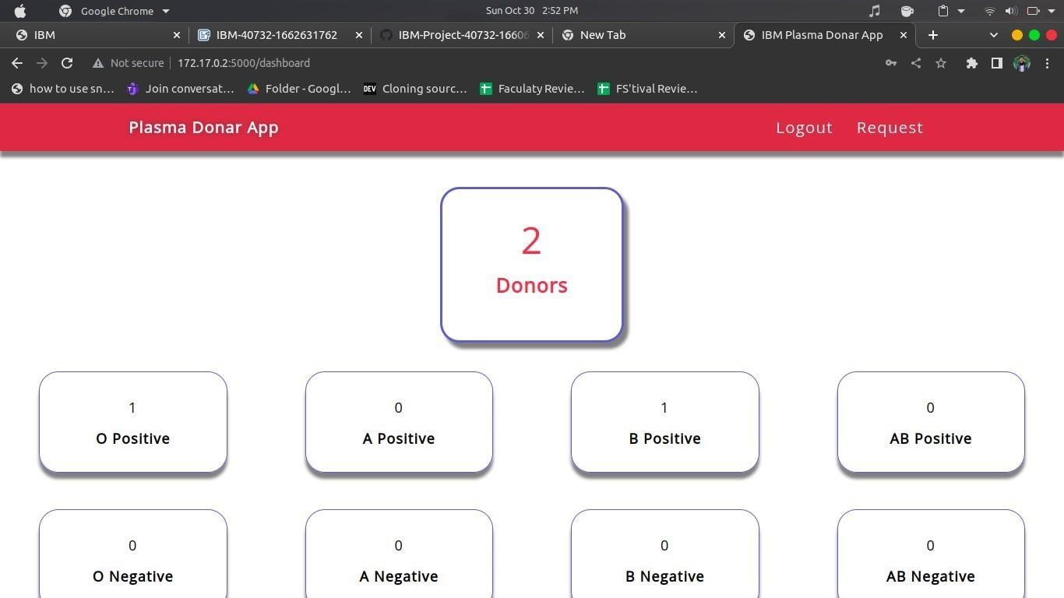

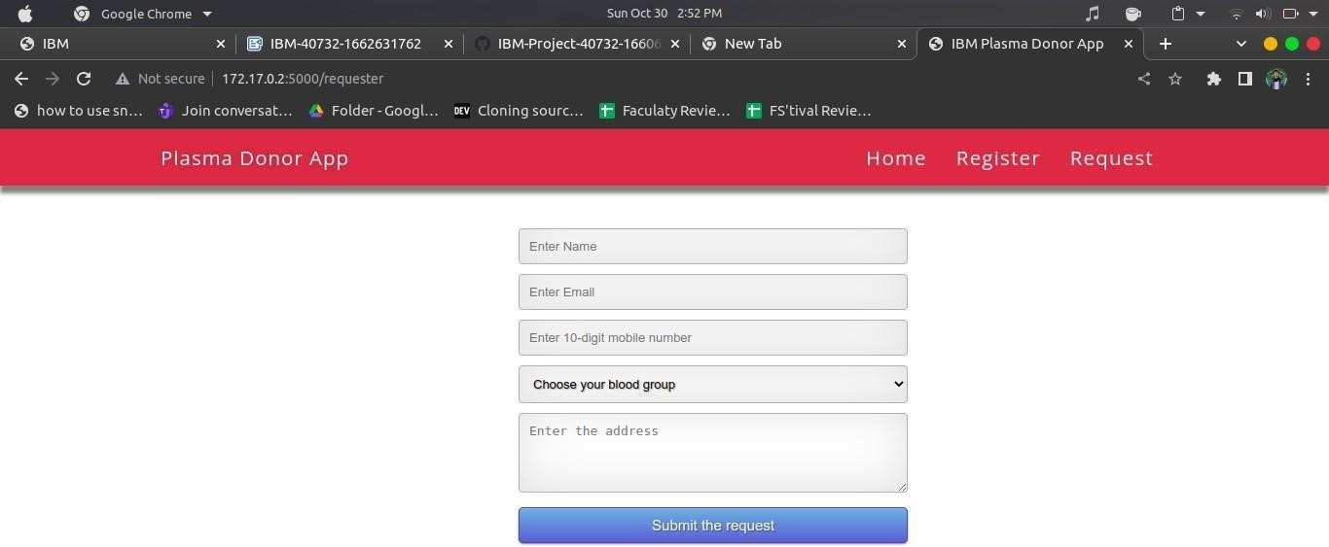

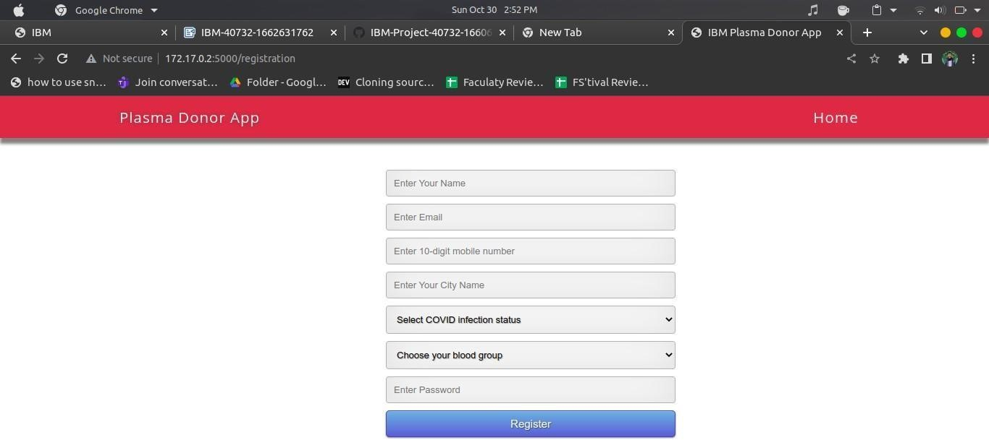

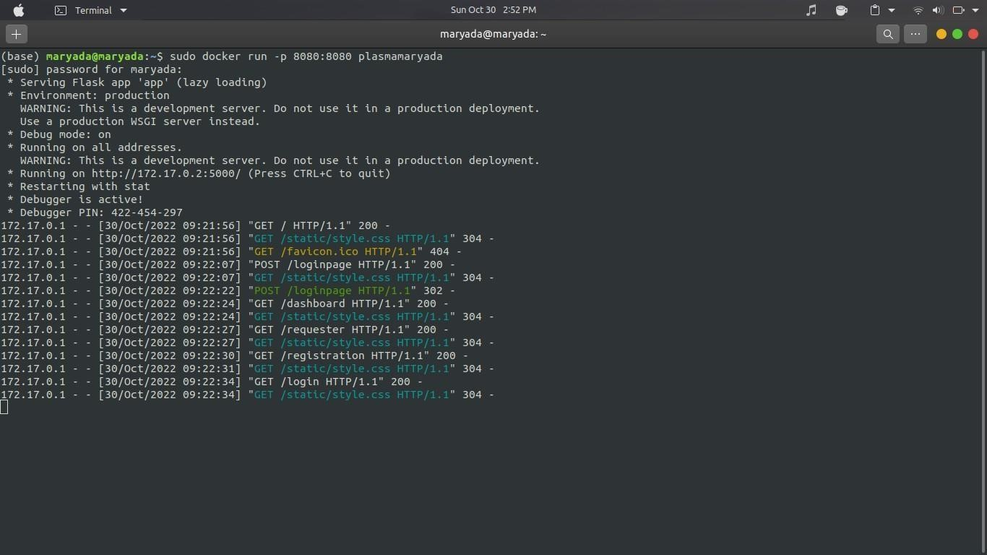

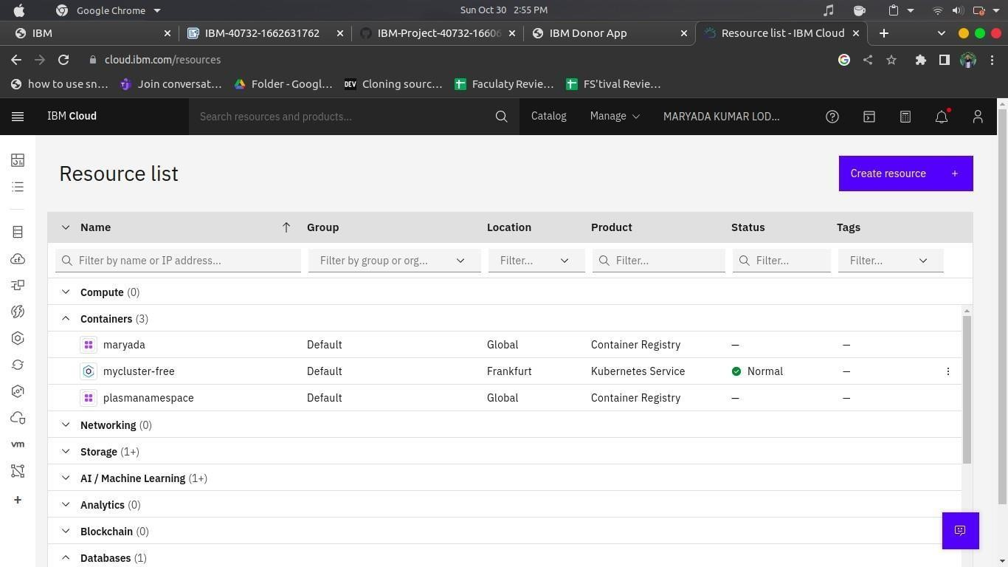

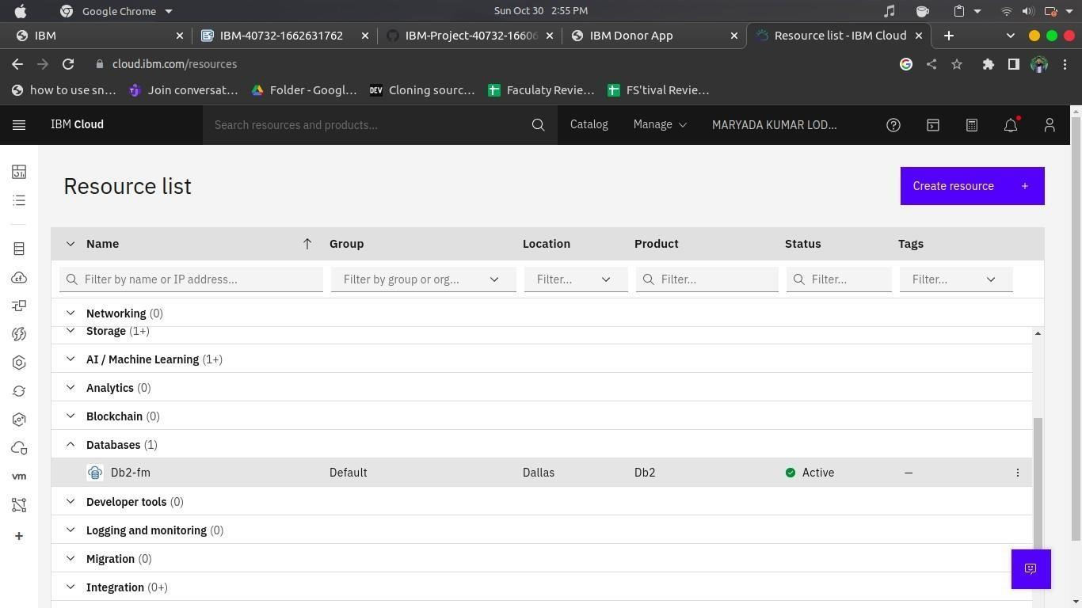

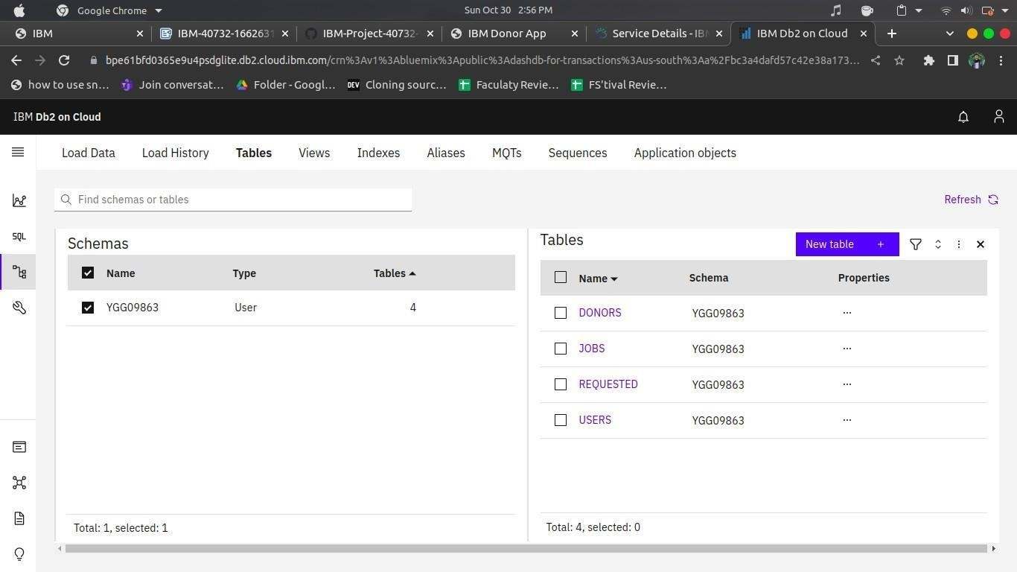

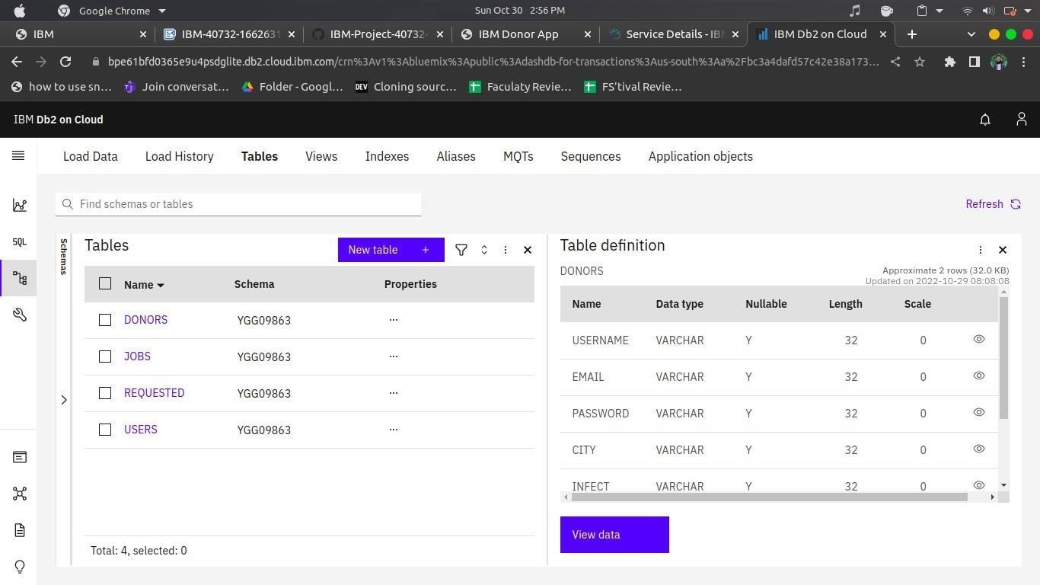

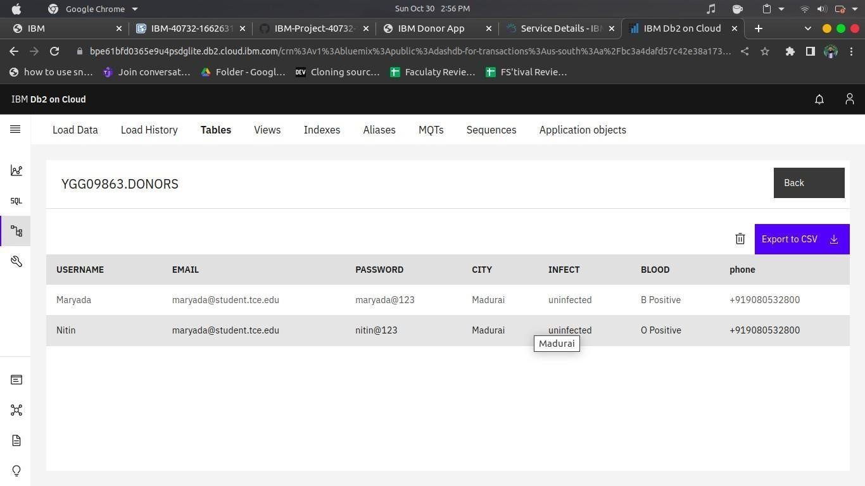

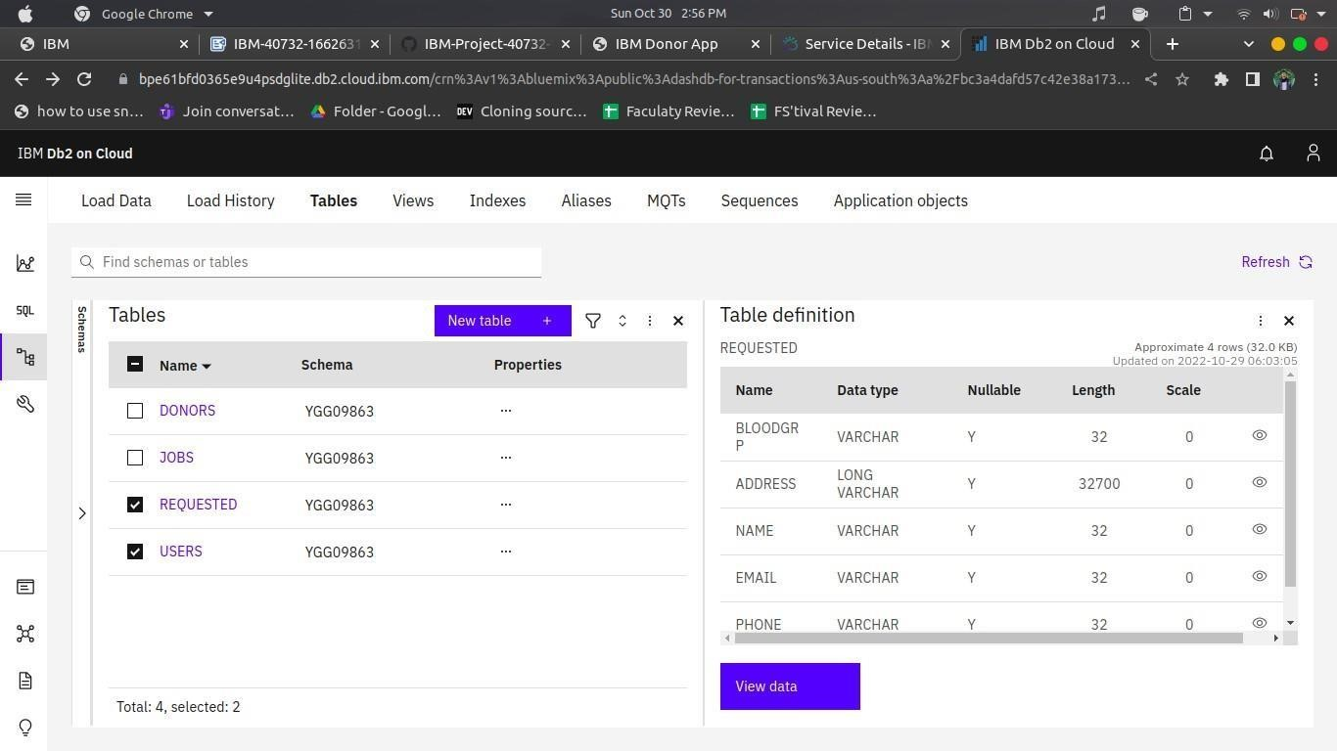

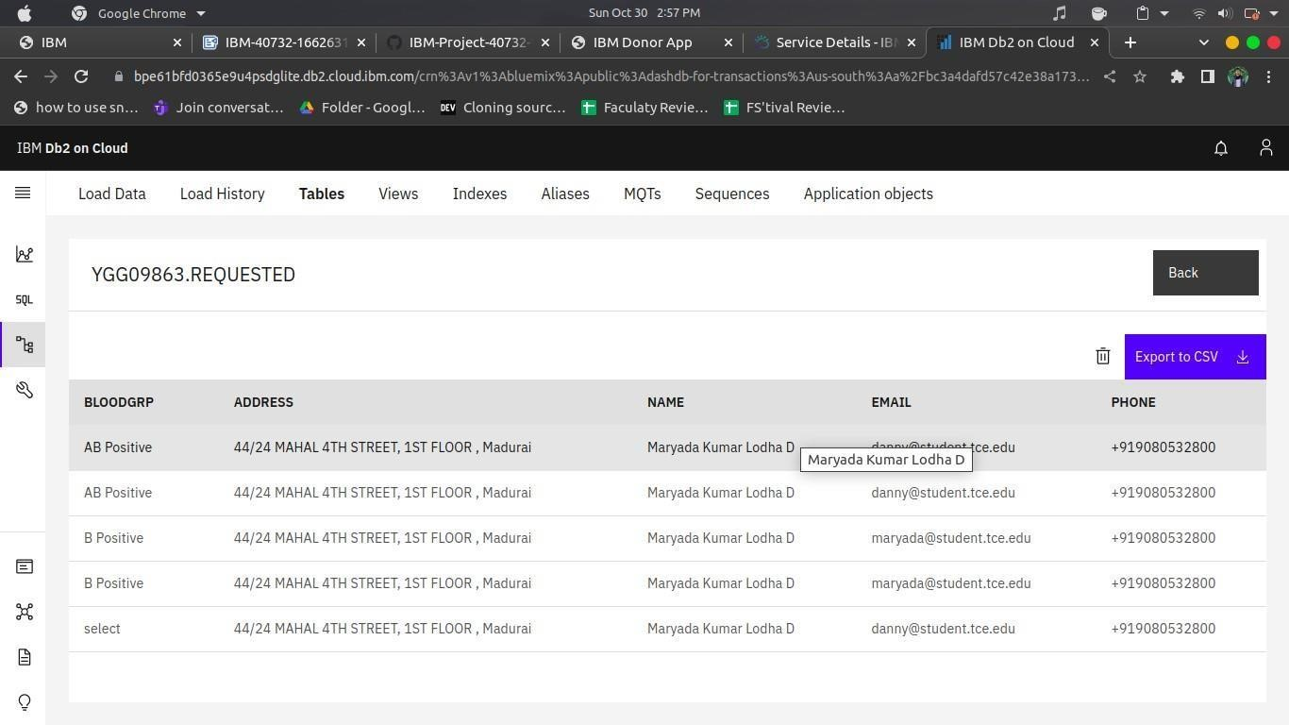

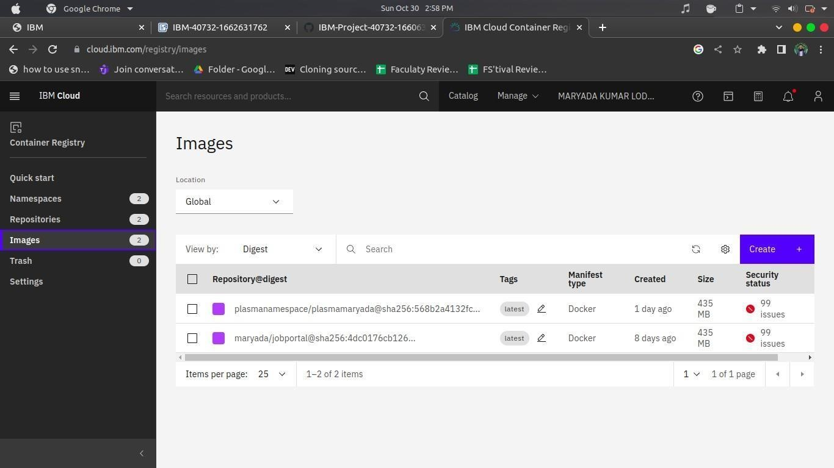

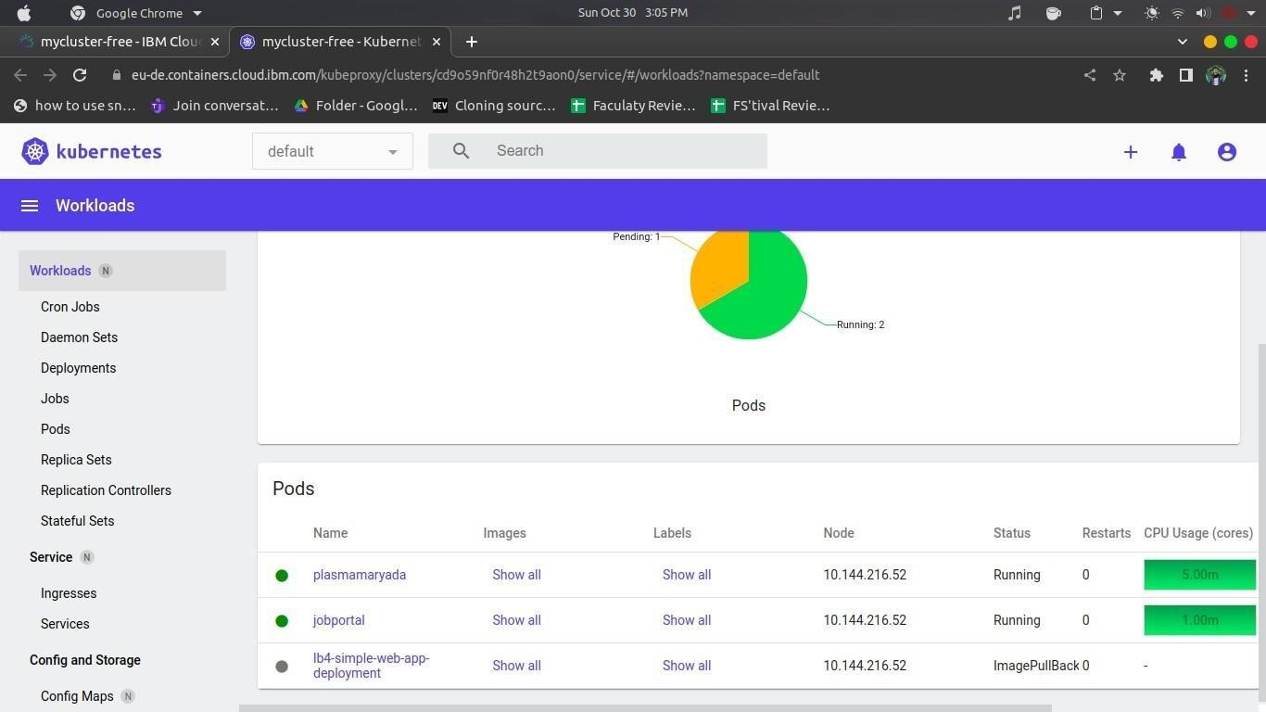

**Source code :** [**https://github.com/IBM-EPBL/IBM-Project-34196-1660232552**](https://github.com/IBM-EPBL/IBM-Project-34196-1660232552%20)